UK Year 5 – Pre-test
12 Questions | 30-45 minutes | Calculator not allowed
1. Find the factors of these numbers.
27: _________,_________,_________,_________

15: _________,_________,_________,_________

12: _________,_________,_________,_________,_________,_________

2. Find and circle the multiples of the given number.
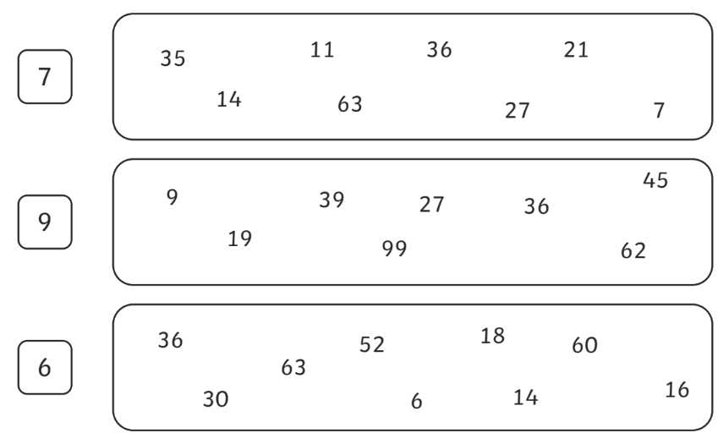

3. Calculate the following questions, show your strategies in your working out.

7890 + 3405 | 4391 – 2186
1359 $×$ 27 | 3901 $÷$3
4. Order these fractions from smallest to largest.
You may wish to write the fractions with a common denominator first.
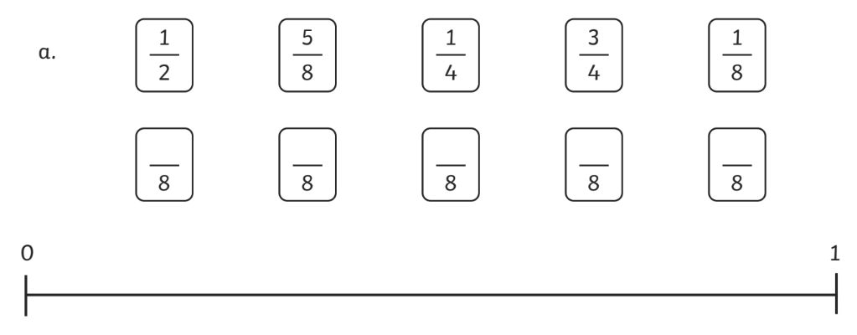

5. Complete the following patterns by finding the rule.

0.1, 0.2, 0.3, ____________, ____________, ____________, ____________

$\frac{1}{4}$, $\frac{1}{2}$,$\frac{3}{4}$, ____________,$1\frac{1}{4}$ ____________, ____________, ____________
6. Write the probability of outcomes for each spinner using decimal numbers.
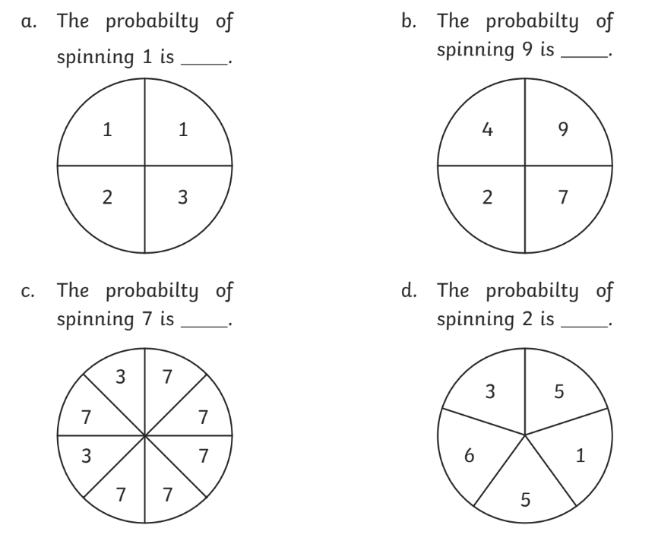
7. Write true or false for each statement.
636 rounds to 600. _________________
178 rounds to 100. _________________
23 rounds to 20. _________________
1389 rounds to 1400. _________________
8. Find the perimeter of the shape.
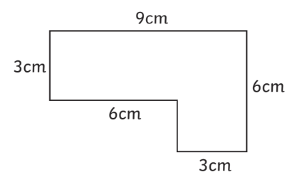 P = __________________________
9. Find the area of the shape and compare them using $<,>,=$.
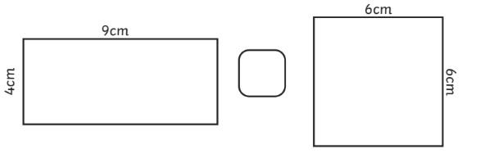
A = __________________________ | A = __________________________

10. Complete the grid by writing the coordinates,
translations and new coordinates of each space object.
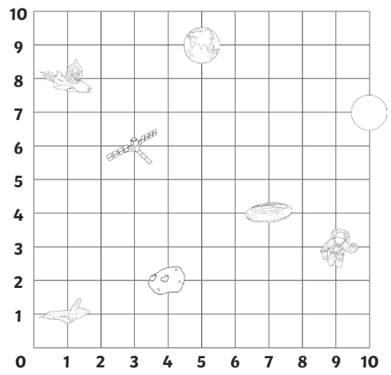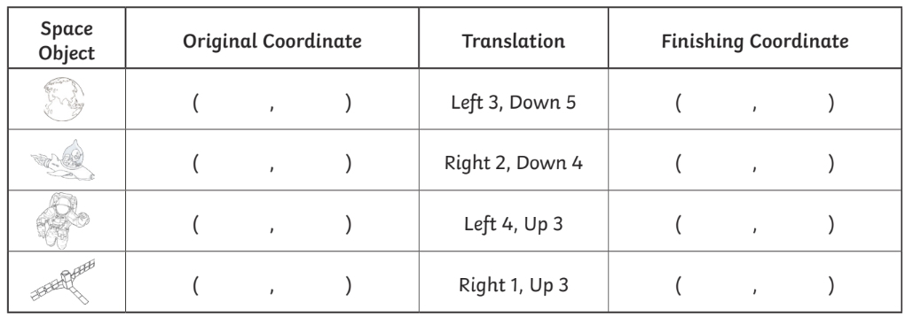

11. Name and interpret these two sets of data.
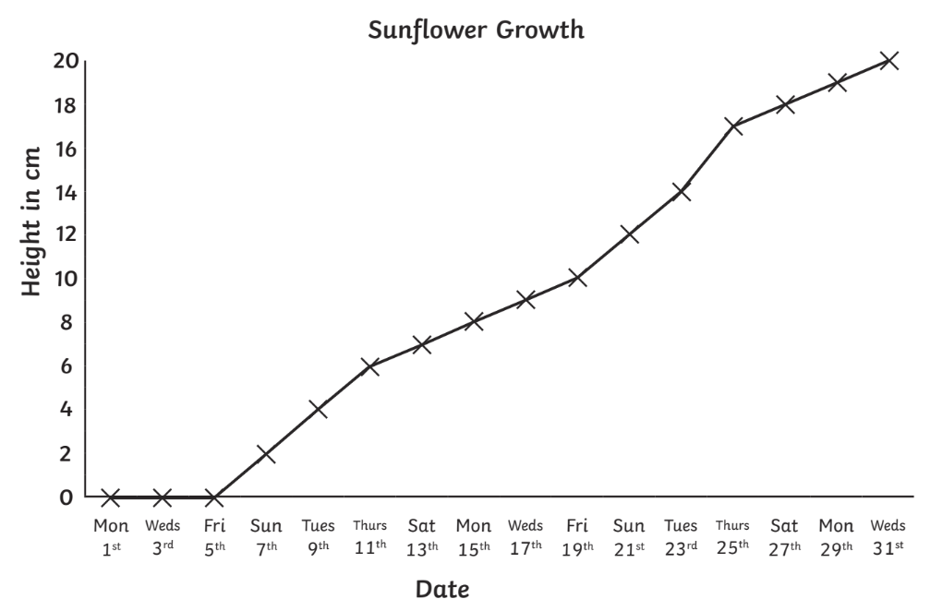
What type of graph is this? | ________________
What is the maximum height? | ________________
When did the growth begin? | ________________
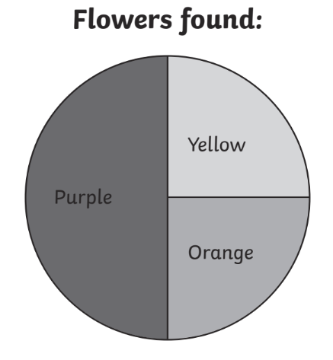
What type of graph is this? | ________________
Write a fraction to show the probability of a purple flower being found. | ________________
What are the chances of fidning a blue flower? | ________________

12. Liam was sick last Friday.
Liam went to the doctor. There are 8 patients waiting.
The nurse told him it will be his turn after 2 hours.
How many minutes would the doctor use to see each patient?

_________________________________ minutes.

